Launch an EC2 instance (Linux and Windows) along with a web server. Then, create an EBS volume of 5 GB, attach it to an EC2 machine (Linux and Windows), and take a snapshot. Finally, create an EBS volume using the taken snapshot.

Elastic Block Storage (EBS): From the aforementioned list, EBS is a block type durable and persistent storage that can be attached to EC2 instances for additional storage. Unlike EC2 instance storage volumes which are suitable for holding temporary data EBS volumes are highly suitable for essential and long term data. EBS volumes are specific to availability zones and can only be attached to instances within the same availability zone.

EBS can be created from the EC2 dashboard in the console as well as in Step 4 of the EC2 launch. Just note that when creating EBS with EC2, the EBS volumes are created in the same availability zone as EC2, however when provisioned independently users can choose the AZ in which EBS is required

Types of EBS Volumes:

SSD: This storage type is suitable for small chunks of data that requires fast I/Ops. SSDs can be used as root volumes for EC2 instances.

General Purpose SSD (GP2)

Offers a single-digit millisecond latency.

Can provide 3000 IOps burst.

IOps speed is limited from 3-10000 IOps.

The throughput of these volumes is 128MBPS up to 170GB. After which throughput increases

768KBPS per GB and peaks at 160MBPS.

Provisioned IOPS SSD (IO1)

These SSDs are IO intensive.

Users can specify IOPS requirement during creation.

Size limit is 4TB-16TB

According to AWS claims "These volumes, if attached to EBS optimized instances will deliver IOPS defined within 10% 99.9% times of the year"

Max IOPS speed is 20000.

HDD: This storage type is suitable for Big Data chunks and slower processing. These volumes cannot be used as root volumes for EC2. AWS claims that "These volumes provide expected throughput 99.9% times of the year"

Cold HDD (SC1)

SC1 is the cheapest of all EBS volume types. It is suitable for large, infrequently accessed data.

Max Burst speed offered is 250 Mbps

Throughput optimized HDD (ST)

Suitable for large, frequently accessed data.
Burst speed ranges from 250 MBPS to 500 MBPS.

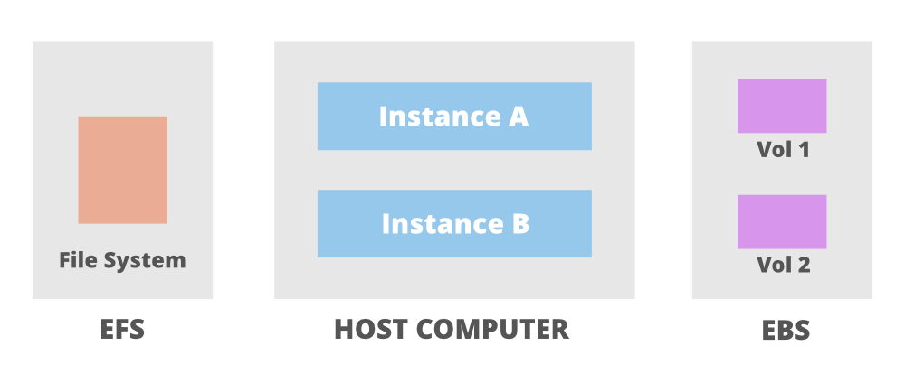

Database storage: Given the low latency and scalability offered by EBS it is highly suitable for storing relational as well as NoSQL databases.

Business intensive applications: Given the scheduled backup offered by EBS as snapshots the recovery of data is quick and a refreshed system can be rebooted efficiently with minimal data loss.

Hard Disks for EC2 servers: EBS volumes can be used as hard drives to your EC2 servers. They are independent of your EC2 servers and hence your data in these volumes is safe even if EC2 servers fails/reboots/terminate

Hosting Large Applications: EBS provides an exceptionally low latency period amounting to a great computing power of the architecture. It can be used to hold big enterprise application software and data.

Root Volumes for EC2: EBS types GP2 and IO1 can be used as the root volumes for your EC2 server.

Amazon Elastic Block Store (EBS)
It provides persistent block-level storage volumes for use with Amazon EC2 instances.1 Think of an EBS volume as a virtual hard drive that you can attach to your virtual server.
Its most important feature is persistence. By default, an EC2 instance's root volume is often deleted when the instance is terminated, meaning all data on it is lost. An attached EBS volume, however, exists independently. Its data remains intact even if the instance is terminated, and it can be detached and re-attached to another EC2 instance, making it essential for any application that needs to store data reliably.

This guide will provide a step-by-step walkthrough for two common scenarios:

Attaching a new volume when launching a new EC2 instance.

Creating and attaching a volume to an already running EC2 instance.

The crucial final steps of formatting and mounting the volume inside Linux to make it usable.

EBS Volume Types:

- SSD
- HDD
- Magnetic Disk

Step To Attach EBS Volume in EC2-Instance:

Step 1: Go to All services and click on EC2

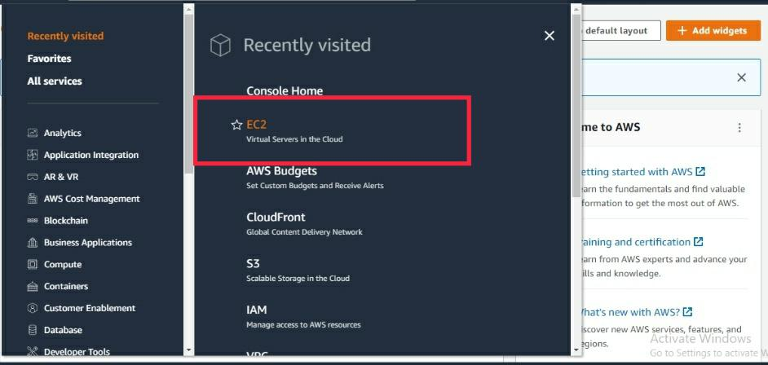

Step 2: Click on the Launch Instance.

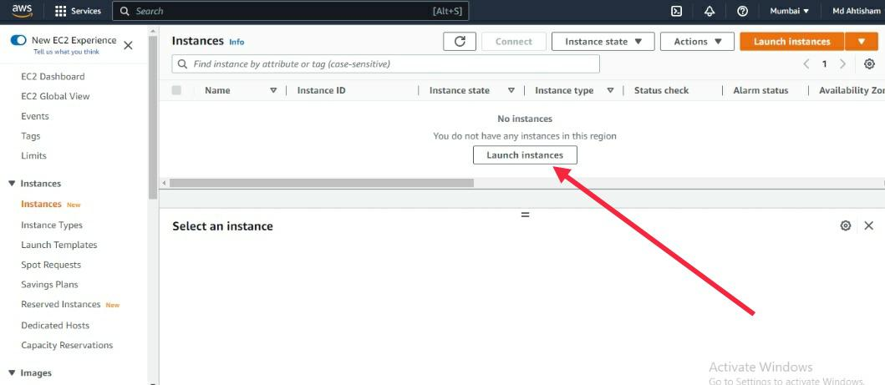

Step 3: Give the EC2 instance name or tag like the "EBS-Volume" name.

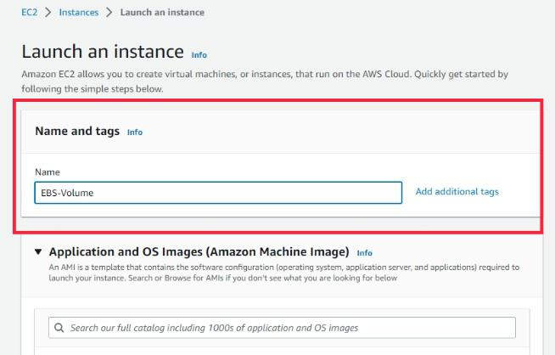

Step 4: Choose Amazon Machine Image for your instance.

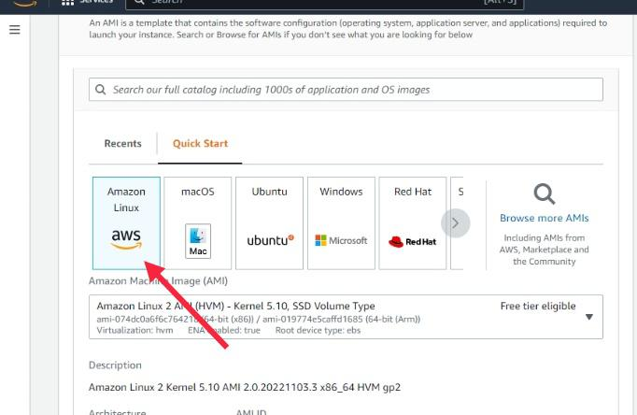

Step 5: Choose an Instance type.

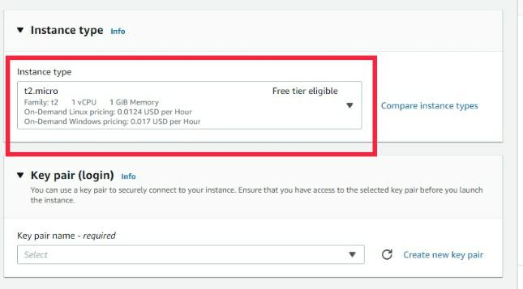

Step 6: Choose the Key Pair or Create the Key pair.

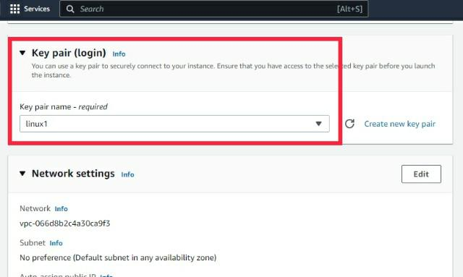

Step 7: Create the Security Group then open the port as per your requirement

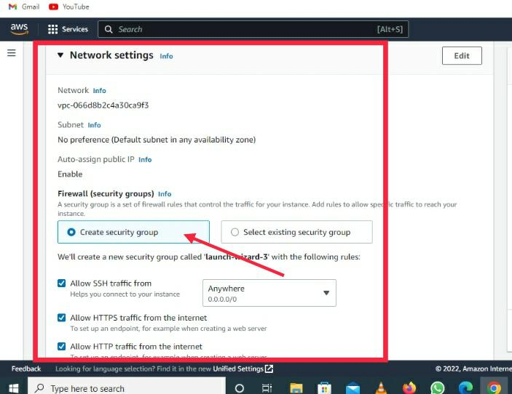

Step 8: Click on the Add new Volume for the extra EBS Volume. '2' is denoting how to attach EBS

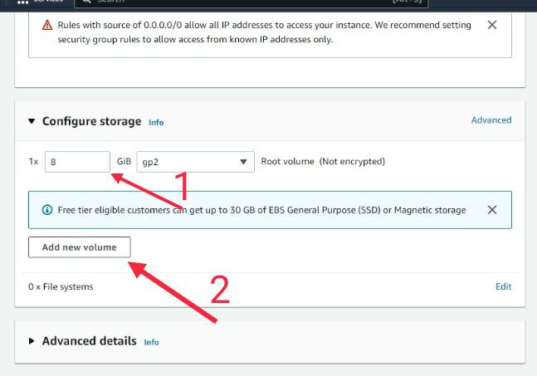

Step 9: Configure the EBS Size.

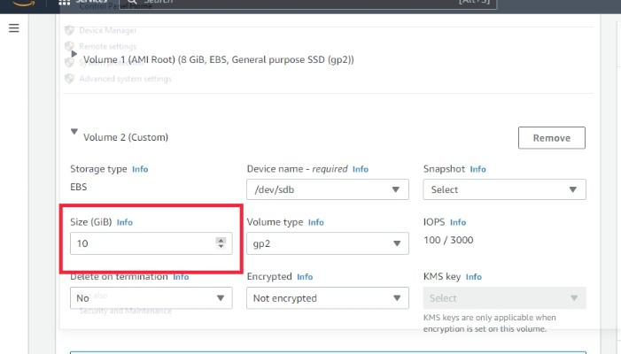

Step 10: Select the EBS type as per your requirement.

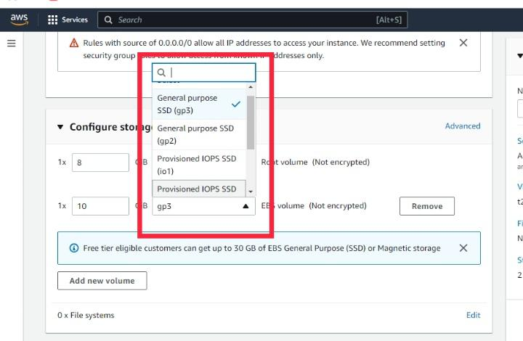

Step 11:Click on the Launch Instance button.

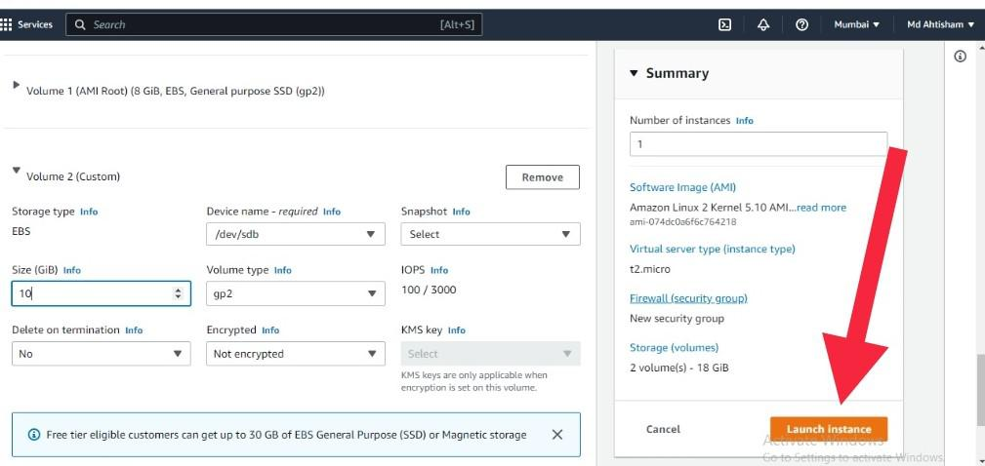

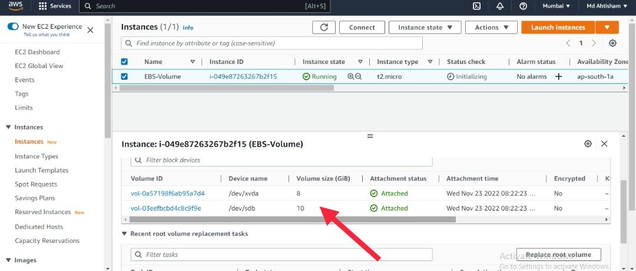

Step 3: Attach EBS Volume to EC2 Instance

Select Volume: In the AWS Management Console, navigate to the EC2 Dashboard and click on the "Volumes" option in the left-hand navigation pane. Select the volume you want to attach by clicking on its row in the volume list.

Click Action Button: After selecting the volume, locate the "Actions" button above the volume list and click on it.

Choose Attach: From the dropdown menu that appears after clicking the "Actions" button, select the "Attach Volume" option.

Select Instance: In the "Attach Volume" dialog box, select the instance to which you want to attach the volume from the dropdown menu. Ensure that the instance and the volume are in the same availability zone.

Specify Device: After selecting the instance, specify the device name for the volume in the "Device" field. This is the device name that will be used to mount the volume on the instance (e.g., /dev/sdf).

Attach Volume: Once you have selected the instance and specified the device name, click the "Attach" button to attach the volume to the instance.

Confirmation: After clicking "Attach", you will receive a confirmation message indicating that the volume has been successfully attached to the instance.

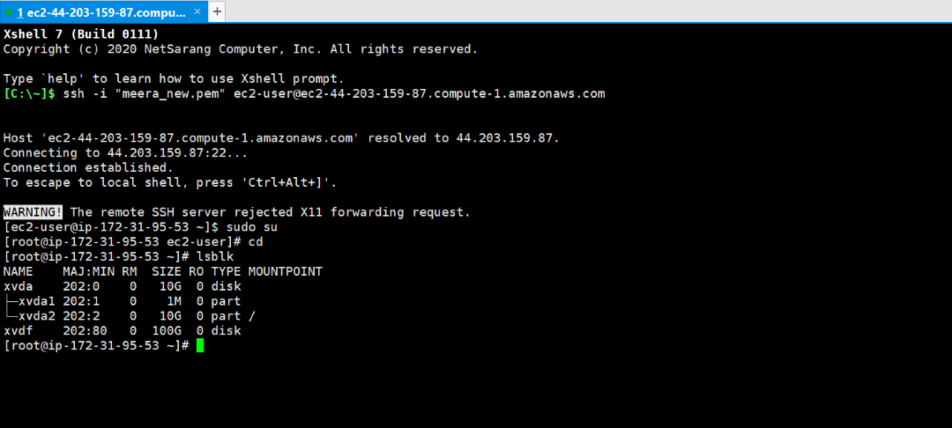

Step 4: Connect to your EC2 Instance

SSH Connection: Open your terminal or command prompt and use the SSH command to connect to your EC2 instance. Replace your-ec2-instance-ip with the public IP address of your EC2 instance, and your-ec2-key.pem with the path to your private key file:

ssh -i /path/to/your-ec2-key.pem ec2-user@your-ec2-instance-ip

$ sudo su
$ cd

You can now list the disk available on your EC2 instance by firing the below command.

Step 5: Create a Filesystem on the EBS Volume
Using the following command, format the volume as ext4 filesystem.
$ mkfs.extr /dev/xvd
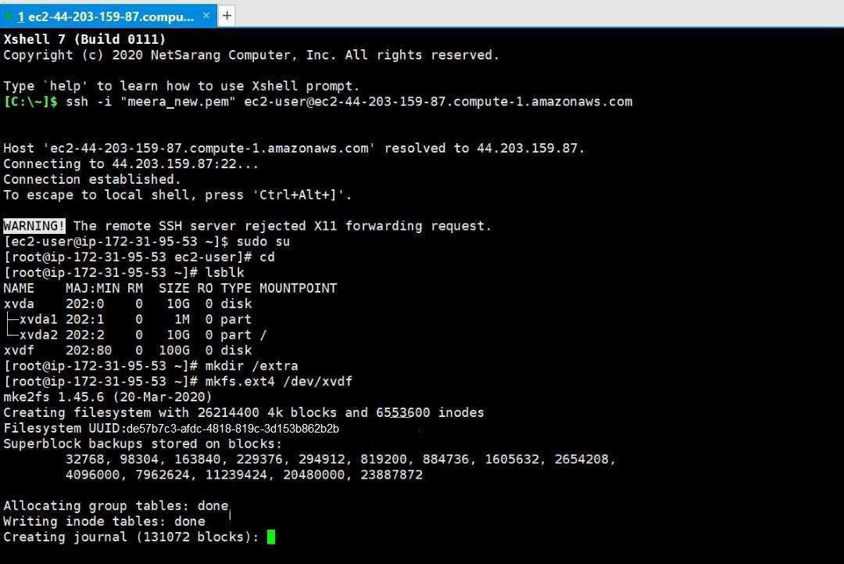

Step 6: Mount the EBS Volume
View all the disks which are attached to the instance by using following command.The output of lsblk removes the /dev/ prefix from full device paths.

Paste the UUID and the path where you want to mount and the filesystem you format.
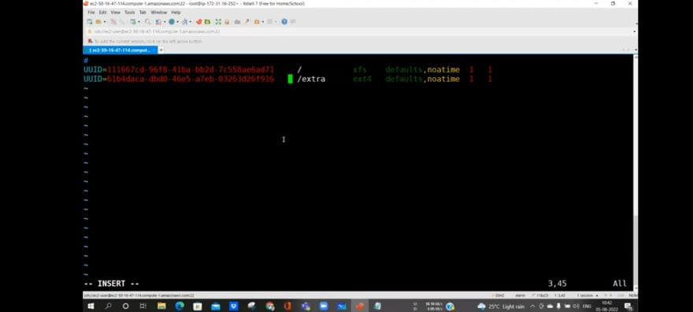

Steps to add Multiple EBS Volumes to EC2 Instance

Step 1: Use the following command to attach the ebs volume with aws ec instance in the following command just teplace few things like <volume-id>,<instance-id> with the your IDs.
aws ec2 attach-volume --volume-id <volume-id> --instance-id <instance-id> --device /dev/xvdf

Step 2: Do the formating on the EBS volume by using file system with the help of following command.
mkfs.ext4 /dev/xvdf

Step 3: Mount the EBS volumes which are formatted and attached to the EC2 you can use the following command to mount.
mount /dev/xvdf /mnt/ebs

Step 4: Click attach after selecting the instance to which you want it to attach. The instance has now been given access to your volume. Now use the instructions below to connect to the root.
$ sudo su
$ cd

Step 6: You can now list the disk available on your EC2 instance by firing the below command.
lsblk

Step 7: For a detailed description of the volumes throw the below commands.

$ fdisk -l

Step 8: If you want to check whether the disk is mounted to the server or not. You can use the below command

$ df -h

Step 9: Using the following command, format the volume as ext4 filesystem.

$ mkfs.extr /dev/xvdf

AWS EBS (Elastic Block Store) Snapshot

Data is the most important thing anywhere over the internet. Everyone wants to be more secure and save when it comes to their Data security. Data on your Amazon EBS volume can also be back up to Amazon S3 Bucket by taking a point-in-time Snapshot. Snapshots can be used to create a backup of critical workloads, such as a large database or a file system that spans across multiple EBS volumes.

Amazon EBS Snapshots

EBS Snapshots are point-in-time images or copies of your EBS Volume. These are stored on S3, which can be accessed through Elastic Cloud Computing APIs or AWS Console. While EBS volumes are availability zone (AZ's) specific but, Snapshots are Region-specific. Your Snapshot size must be either same or larger than the size of the original volume from which the snapshot is taken. As per Amazon, each AWS account can have a maximum of up to 5000 images or copies Volumes and up to 10,000 EBS Snapshots created. A snapshot, when created, shows a 'pending ' status, which then converts into 'complete' once the snapshot creation is successful.

How Do Snapshots Work

Snapshot is a backup of root storage that is attached to the EC2-Instance to know how to create AWS EC-instance refer to Amazon EC2 – Creating an Elastic Cloud Compute Instance. The snapshot which you are going to take at first it consist of all the data which is present in the EBS eventually snapshots you are going to take will consist only the data which is newly added and this snapshots are also called incremental snapshots.

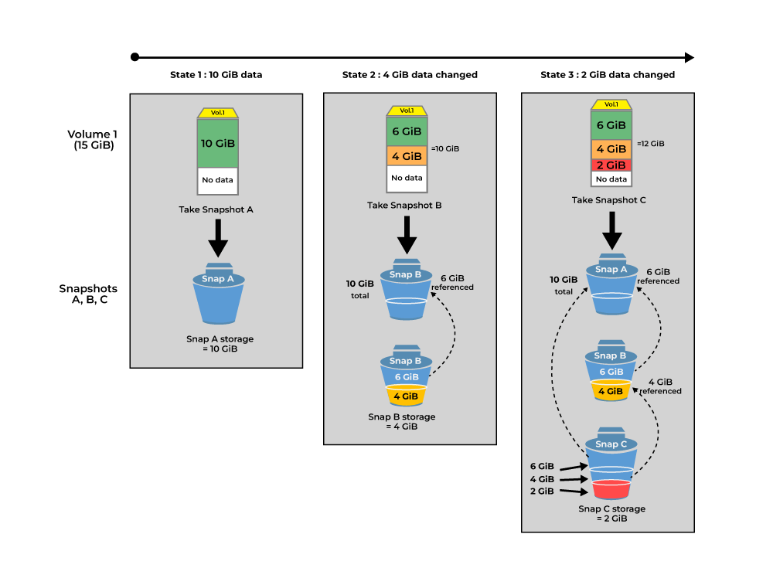

AWS will chanrge you based on the amount of data is going to be backed up in single snapshot. Snapshot source volume will not decide the cost will decide by the amount of data is being backed up. For example if size of EBS volume is 100 GiB and the data you have been backed up is 60 GiB using snapshot then amazon will only charges you for the 60 GiB only.

Copy And Share Snapshots

The data which was been backed up using AWS snapshots will stored in the same region where the EBS volume if located. Snapshots are region contains if you want to share the snapshots across the regions then you need to perform some configurations like enabling multi-region options and so on.

Sharing the snapshots across the multiple AWS accounts can also be achieved by managing the permissions

Encryption Support For Snapshots

Snapshots and the volumes which are created by using each them will be in the state of encryption form.

The snapshots which is copied from the un-encrypted snapshots can be un-encrypted while the process of coping.

If the snapshots is already encrypted before you copy you can re-encrypted the snapshots with the different keys based on your requirements.

The EBS volume created by using the encrypted snapshots then the volume will also be in encrypted format.

Steps To Create Amazon EBS snapshots

Step 1: To create a snapshot of a volume, simply select the AWS console's Volumes container, right-click on the volume and choose the Create Snapshot option from the shortcut menu.

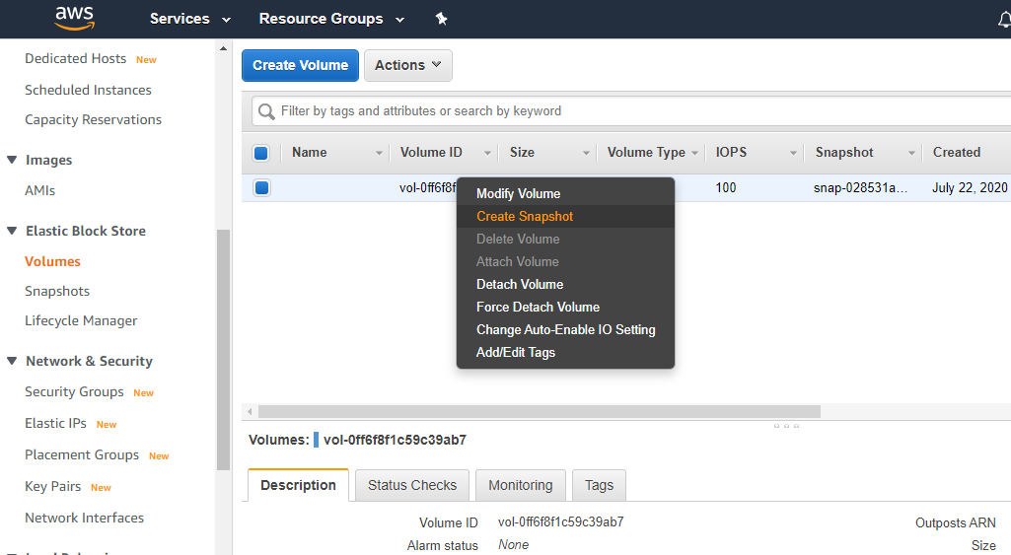

Step 2: After entering the description of the snapshot, click Create to create the snapshot.

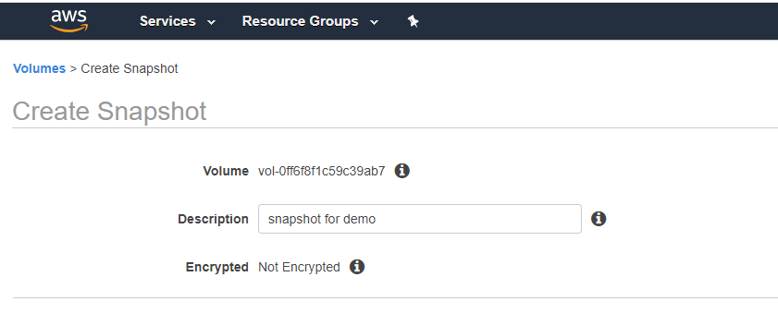

Step 3: A popup will come stating the snapshot creation as started.

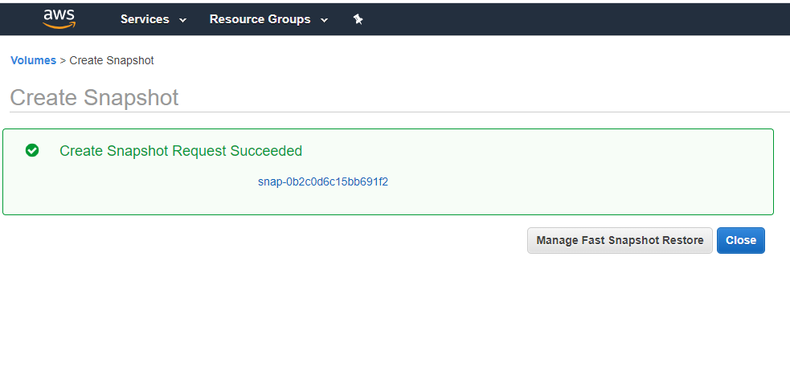

Step 4: You can view the snapshot's status on the console's Snapshots tab.

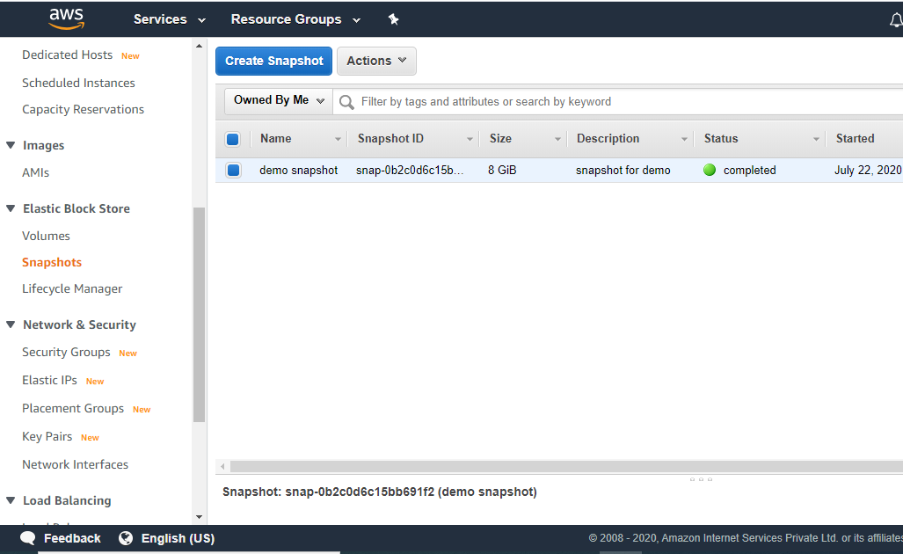

One can not only create a snapshot but also can copy the already created snapshot. This copied snapshot can be shared with other accounts. If you share a snapshot with another account, then that person cannot directly create volume out of the shared snapshots. For creating volume from such a snapshot that person first needs to copy the snapshot so that the snapshot is now owned by him and can then create a volume out of it. Both encrypted and un-encrypted snapshots can be shared within the different AWS accounts. But, if you try to copy an encrypted snapshot without having the permissions to the encryption key, the copy process will "fail silently".

How to Delete AWS Snapshot?

Open the Amazon EC2 console ..

Choose Snapshots in the navigation pane.

Select a snapshot and then choose Delete from the Actions list.

Choose Yes, Delete.

AWS Elastic File System

From the aforementioned list, EFS falls under the file storage category. EFS is a file-level, fully managed, storage provided by AWS (Amazon Web Services) that can be accessed by multiple EC2 instances concurrently. Just like the AWS EBS, EFS is specially designed for high throughput and low latency applications.

EFS WORKS :

EFS can be created using the EC2-Instance where it will be created in a specific region and distributed across multiple availability zones for the purpose of high availability and durability. You can choose the EFS based on the I/Ops you are going to perform.

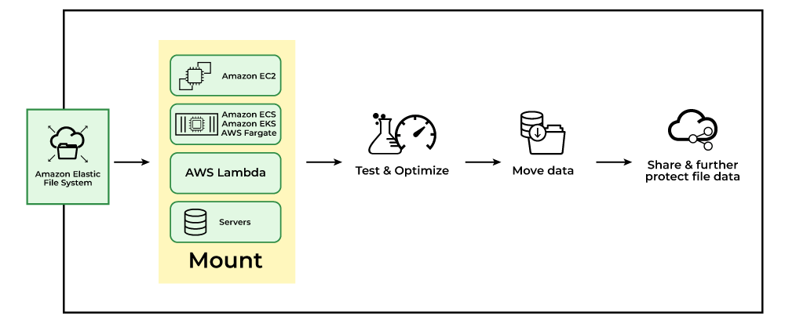

Use Cases Of EFS

Secured file sharing: You can share your files in every secured manner and in a faster and easier way and also ensures consistency across the system.

Web Hosting: Well suited for web servers where multiple web servers can access the file system and can store the data EFS also scales whenever the data incoming is increased.

Modernize application development: You can share the data from the AWS resources like ECS, EKS, and any serverless web applications in an efficient manner and without more management required.

Machine Learning and AI Workloads: EFS is well suited for large data AI applications where multiple instances and containers will access the same data improving collaboration and reducing data duplication.

How AWS EFS Works with Backup?

Amazon Elastic File System (EFS) is a scalable, managed Network File System (NFS) that provides shared storage for Amazon Web Services (AWS) resources such as Amazon EC2 instances and containers.

How AWS EFS Works With Backup and Restore?

AWS EFS provides efficient backups through its seamless integration with AWS Backups and performing restore operations. Through this users can create the backup plans with specifying the backup frequency, retention policies and life cycle management. AWS Backups automate the process of creating and managing the backups ensuring the data integrity and compliance.

How to Create AWS Backup For AWS EFS

Step 1: Now on create AWS EFS Backup on specifying settings as below . You can select template as per your requirement or you can configure backup plan from scratch .

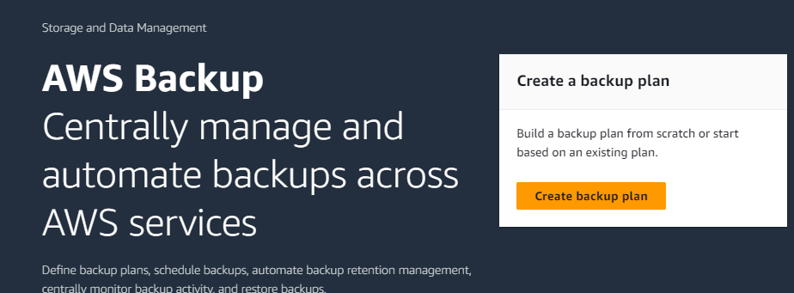

After clicking on the create backup plan, we will be directed for defining the specifications as follows. Choose the specifications as needed.

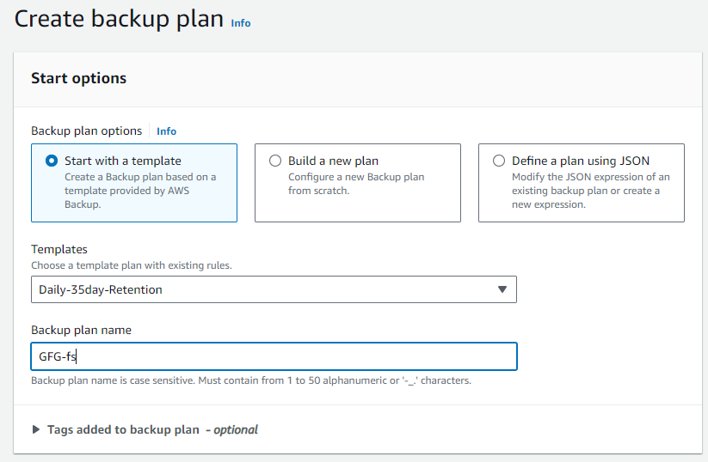

Step 2: Leave other options as default and click create. Once It is created click on Assign. On assign page specify assignment name and select IAM role . We will use default IAM role for now.

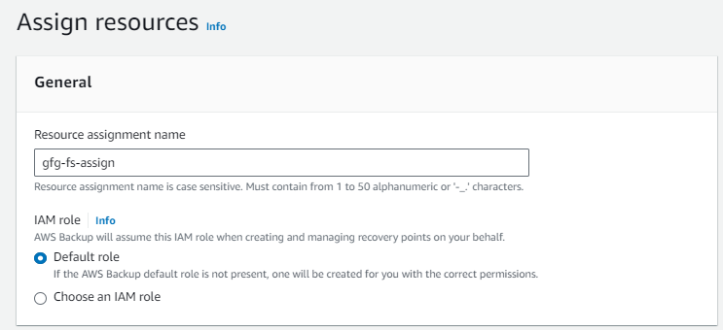

Step 3: Now under resource selection select "Include specific resource type" .

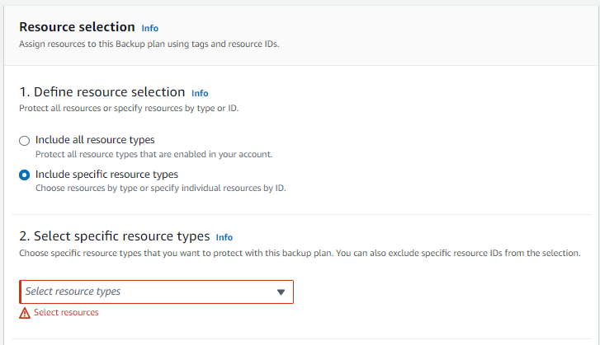

Step 4: Now select specific resource type as "EFS" under EFS select your EFS from dropdown .

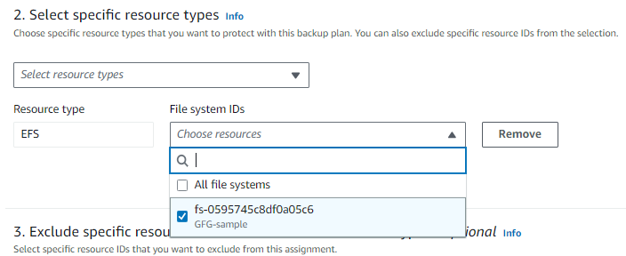

Leave other options as default or specify as per your requirement . Then Click assign .

Once this is done the EFS is associated with backup plan . It will be backup daily for retention period of 35 days as we have specified . You can configure backup plans as your requirement for EFS .

How to Delete EFS Backups

Step 1: Access AWS Backup Console

Firstly log in to your AWS Management Console with your credentials and then navigate to AWS Backup Service.

Step 2: Select Backup Vault

Once landed to AWS Backup Service, choose the backup vault that contains the EFS backups you want to delete.

Step 3: View Backup Jobs

Locate the backup job that is associated with the EFS file system you wishing to delete.

Step 4: Delete Backup Job

In the backup jobs, select the backup jobs that you wish to delete and choose the delete option to delete. Confirm once with backup jobs you want delete by entering delete on showing box.

Step 5: Verify Deletion

After deleting the backup jobs ensure whether they are deleted or not from the vault by viewing in the AWS Backup jobs.

How to do EFS-to-EFS Backups

Step 1: Setup Source And Destination EFS file systems

Firstly ensure you have both the source and destination EFS created and accessable in your AWS Account.

Step 2: Use Data Sync

Now, Try on using AWS Service such as AWS Data Sync a service that is designed for fast and secure data transfers between EFS systems.

It Configures the DataSync tasks to sync data from the source EFS file system to the destination EFS file system.

Step 3: Schedule Sync Tasks

Configuring the DataSync, set up a schedule for DataSync tasks to regularly sync data between source and destination EFS file systems to ensures the backups to be up to date.

Step 4: Monitor And Manage

Regularly monitor the DataSync tasks to ensure smoothly running and resolve troubleshooting issues if any arise. Adjust the scheduling or configurations as needed to optimize the performance and resource usage.

How To Restore an Amazon EFS file system using AWS Backup

Step 1: Access AWS Backup Console

Firstly login your AWS Management Console with your credentials and navigate to your AWS Backup Service.

Step 2: Select Recovery Points

Choose the backup vault that contains the desired looking EFS file system backups.

Select the specific recovery point (backup) you want to restore from.

Step 3: Initate Restore Job

Click on the "Restore" option and provide the details such as the target region and file system settings for restoring process.

Step 4: Review and Confirm

Review the restoration details once and then confirm it to inititate for restoring the EFS file system process.

Step 5: Monitor Progress

Ensure to monitor the restoring progress of the job to an Amazon File system in the AWS Backup Console. Once completing the process verify the successful restoration of the EFS system.

AUTOMATIC BACKUPS :

Automatic Backups refers to the process of automating the backups and managing them without any manual interventions. These backups are typically shceduled at regular intervals for ensuring data protection and recovery in case of data disastery cases. Services like AWS Backup offers the automation of backup solutions for various AWS resources for simplifying the backup management and ensuring the data resilience with minimal efforts from the user.

How Turn Automatic Backups On or Off For Existing File Systems

Step 1: Access EFS Console

Firstly login in to your AWS Account with your credentials and navigate to the Amazon EFS service page.

Step 2: Select File System

Choose the existing Elastic File System for which you want to manage the automatic backups.

Step 3: Modify the Backup Settings

In that configuration of selecting EFS service, under the backup tab, Customize the Automatic Backups settings to turn on or off according to the preference.

Concurrent Backups

Concurrent Backups refers to the capability of a system to execute multiple backup processes simultaneously. This feature facilitates with more efficient use of resources and faster backup completion times. It is especially used in environments with large datasets or high backup demands.
Backup Performances

Backup Performance is a measure of speed and efficiency in performing the backup operations. It includes the factors such as backup speed, throughput and resource utilization. Optimization of backup performance provides timely and reliable data protection which minimize the impact on system resources and operations.

